**Menu Add: ARS Alumni Association**

**Committee**

**Constitution**

**Lifetime Members**

**Batch Co-ordinator**

**Advisor Committee**

**General Members**

**Premium Members**

**Bangladesh Railway Govt. High**

**School, Akhaura**

**Akhaura Railway School Alumni Association**

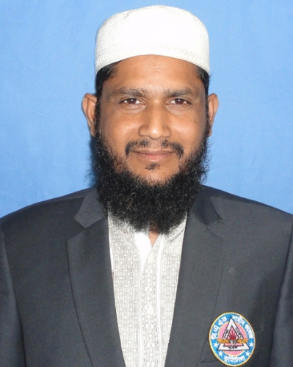

Rabbi Miah

Deputy Commissioner

Narayanganj

Bangladesh Police

General Secretary

Akhaura Railway School Alumnai Association

Chowdhury Abdullah Al-Mamun

DIG, Dhaka Range

Bangladesh Police

President

Akhaura Railway School Alumnai Association